

College of Computer Studies – Documentation [Title]
NSSECU3-Groupings-Solo-Duo-3-4 8
Version <Number>

Version Number | Date | Details
x.x | YYYY/MM/DD | <Brief Description of Changes>

Change Control [Heading 2]

Documentation

Documented from <YYYY/MM/DD>

Authors [Heading 2]
- Balcueva, Joshua Chupungco: <Email>
- Del Rosario, Michael Gabriel Austria: michael_gabriel_delrosario@dlsu.edu.ph
- Fulcher, Lander Gabriel Aviso: <Email>
- Villanueva, Ryan Delos Santos: <Email>

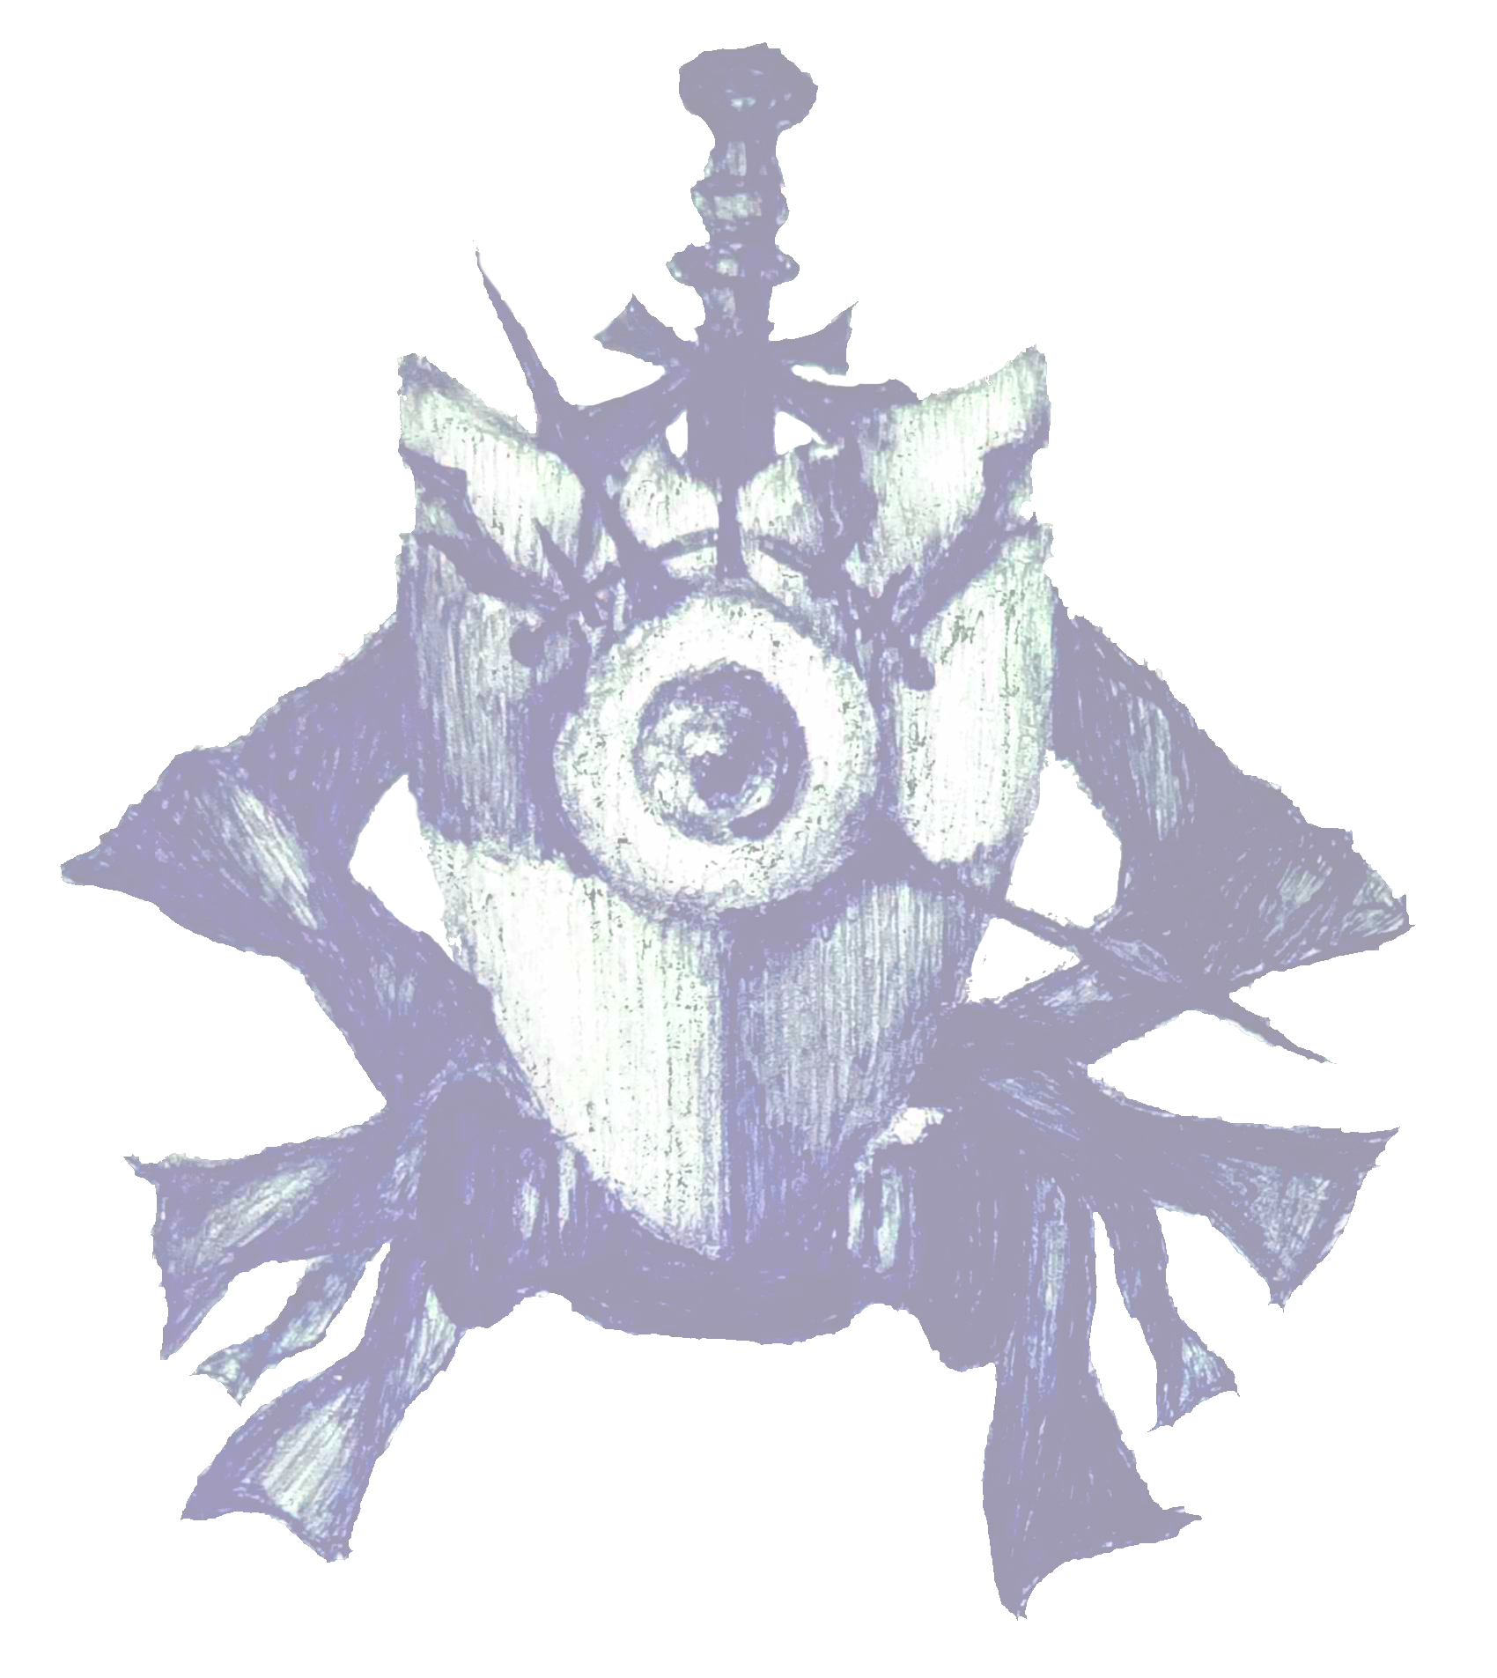

Table of Contents
I. Change Control [Heading 2] 2
II. Authors [Heading 2] 3
III. Table of Contents 4
IV. Summary [Heading 2] 4
A. Objective [Heading 3] 4
B. Overview [Heading 3] 5
V. Details of the Document [Heading 2] 5
A. <Subject Matter> [Heading 3] 5
B. <Subject Matter> [Heading 3] 5
VI. Synthesis [Heading 2] 5
VII. Appendix [Heading 2] 6
A. NSSECU3 Final Song 6
B. enchanted (dfir parody) 6
VIII. Addendums [Heading 2] 7
A. References [Heading 3] 7
B. Glossary [Heading 3] 7

No table of figures entries found.

Table 1. Overview Table 5
Table 2. Synthesis Table 5

Summary [Heading 2]

Objective [Heading 3]
<Elaboration on the objectives of this documentation and its documented material>

B. Overview [Heading 3]
Process | Details
<Step or stage> | <What was done with regards to the documented material, what is the purpose or specific goal of conducting this>
Table 1. Overview Table

Details of the Document [Heading 2]

<Subject Matter> [Heading 3]
<Elaboration on the specified subject matter of the documented material>

<Subject Matter> [Heading 3]
<Elaboration on the specified subject matter of the documented material>

Synthesis [Heading 2]

<Summary of what was documented and the findings>

Findings | Implications | Relevance
Table 2. Synthesis Table

Appendix [Heading 2]

A. NSSECU3 Final Song
The “NSSECU3 final song” is a catchy pop-rock song that explores the digital forensics side of cybercrime. It mentions important topics such as artifacts, registry keys, and digital footprints, which are all essential when understanding how an incident occurred. Overall, the song does a good job of simplifying what Digital Forensics and Incident Response is about and conveying it in a fun and well-produced song.

B. enchanted (dfir parody)
The song is a cover of Taylor Swift’s hit pop song “Enchanted”, but with the lyrics of the song written to explain Digital Forensics in a more in-depth fashion than in comparison to the previous song. It begins with general concepts of Digital Forensics by mentioning how artifacts are not necessarily evidence, using Wireshark to navigate network traffic, using FTK imager to analyze memory, etc. The writers also added some comedic relief to the song by showing their frustration in the topic when they mentioned “Please don't be in love with Windows registry” and “Please don’t be in love with cyber sec”. Although the production, mixing, and writing for the song aren’t perfect, the silliness and content of the song show how much the creators enjoy and have an appreciation for the topic, and listening to the song even becomes somewhat entertaining when being able to relate to it.

Addendums [Heading 2]

References [Heading 3]
<Referenced materials within the report, if any>

Glossary [Heading 3]
<Definitions of technical terms, jargons, and the like, that were used within the report, if any>

